**Experiment-2**

**To understand and apply the concept of Constraints**

Objective: To understand the concept of data constraints that is enforced on data being stored in the table. Focus on Primary Key and the Foreign Key.

1. Create the tables described below:

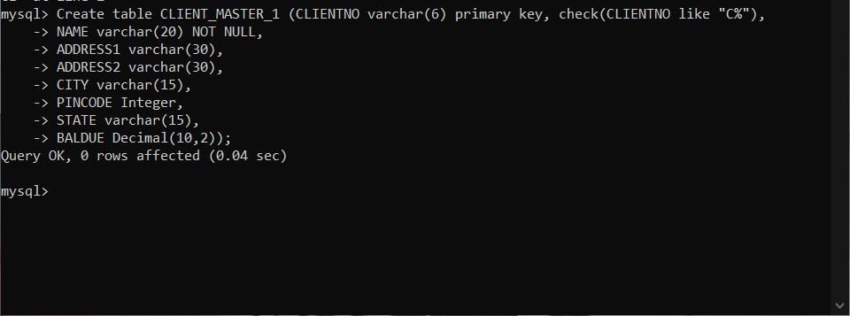

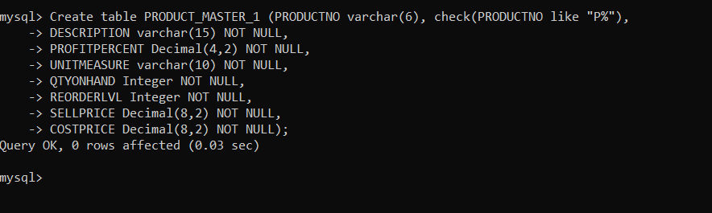

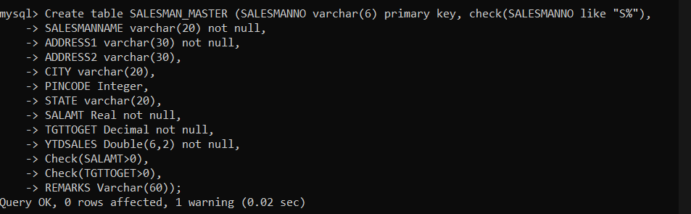

2. Reinsert the data in these two tables based upon Lab 1.

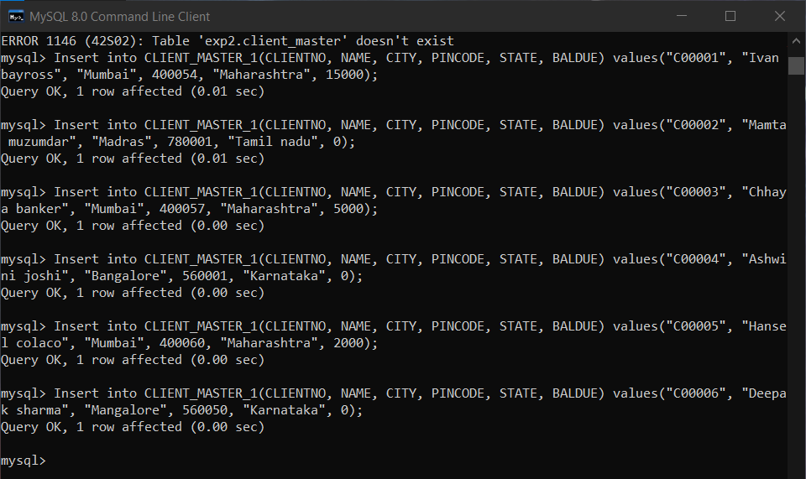

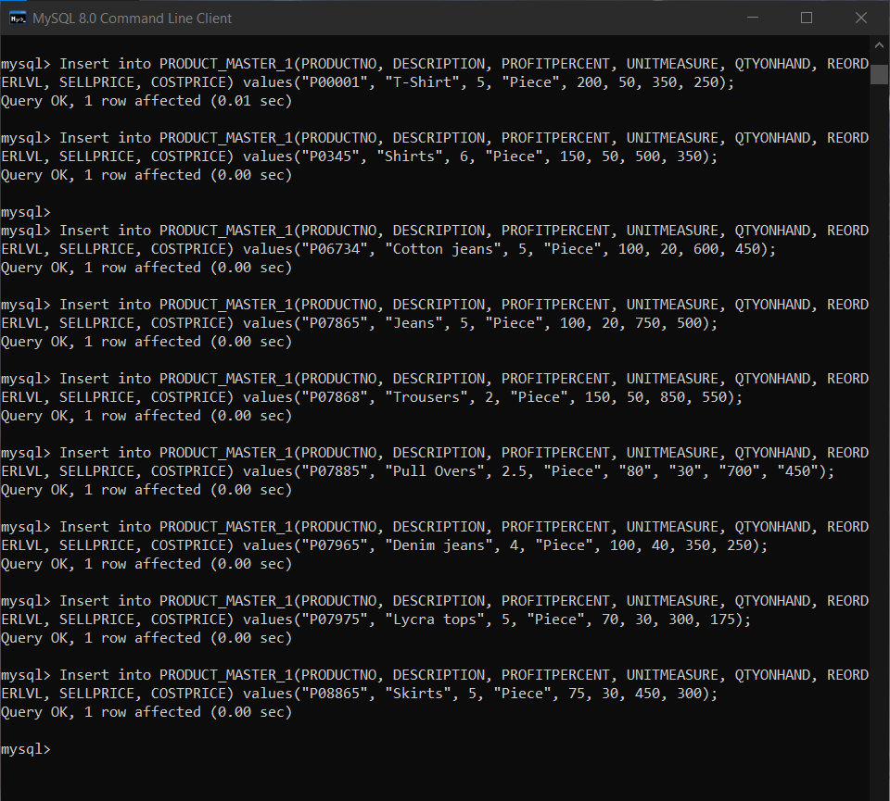

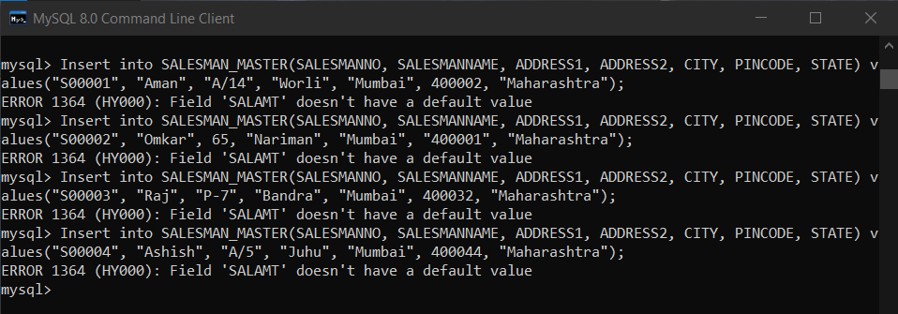

3. Display the contents of each table.

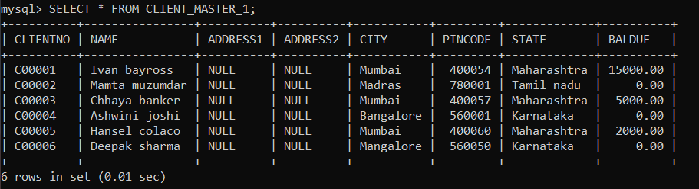

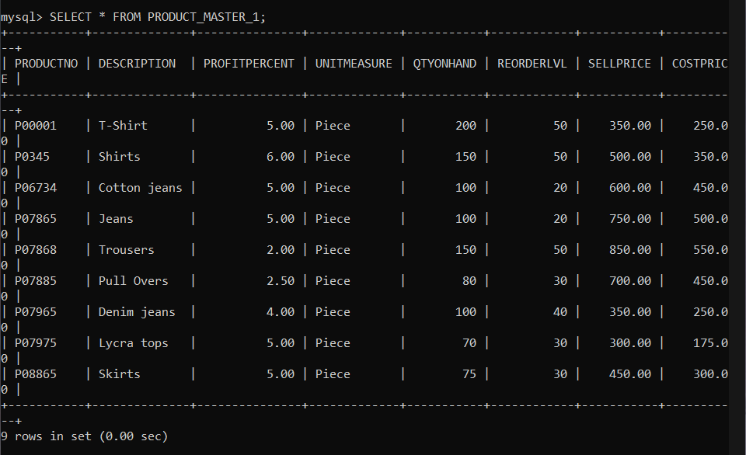

4. Create table AUTHOR = {Author_ID , Lastname, Firstname, Email, City, Country}

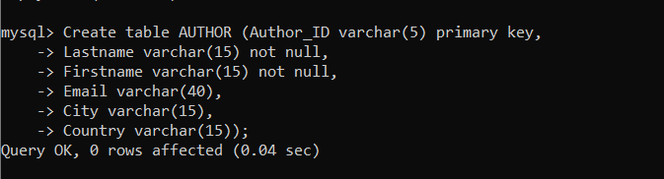

5. Create Table BOOK={ Book_ID, Book_Title, Copies)

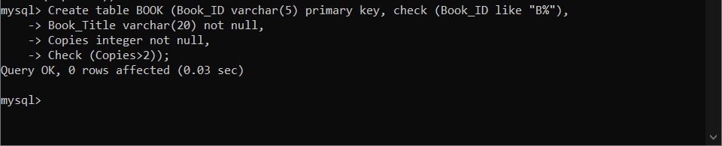

6. Create table AUTHOR_LIST = {Author_ID , Book_ID , Role}

